Can throw checked and unchecked exception.

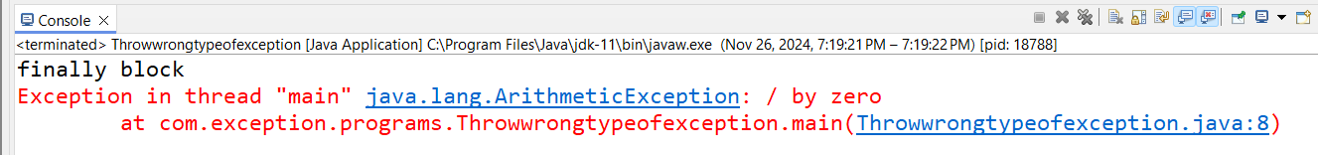



Throws- Can throw checked and unchecked exception only.

